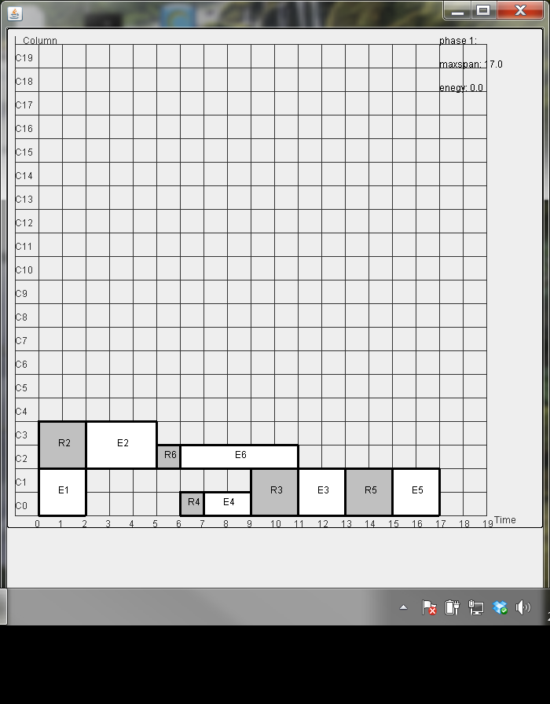

Exmaple 1- with leakage aware placement lk=20, est=0 (est<<lk)

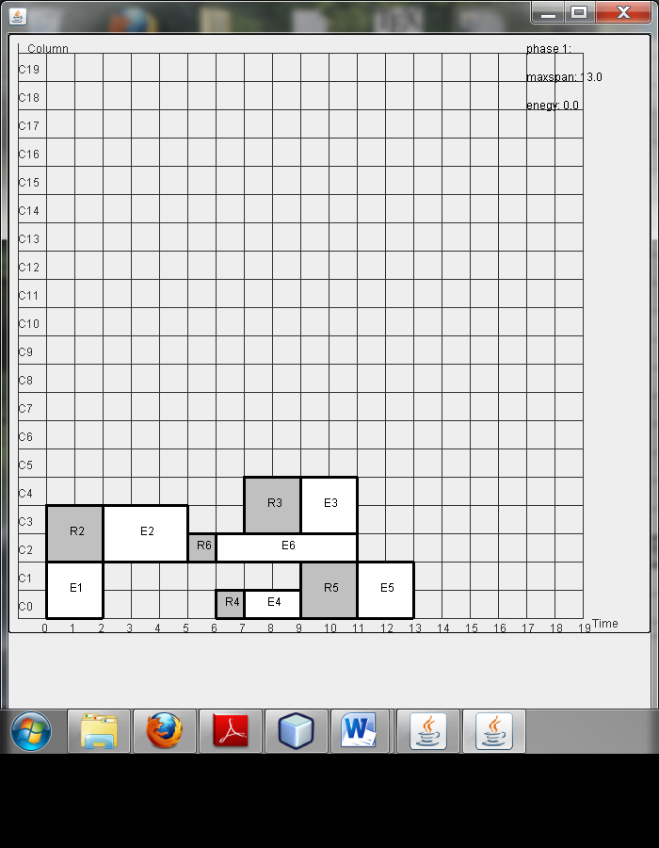

Exmaple 1- with leakage aware placement lk=100, est=1-190 (est<<lk)

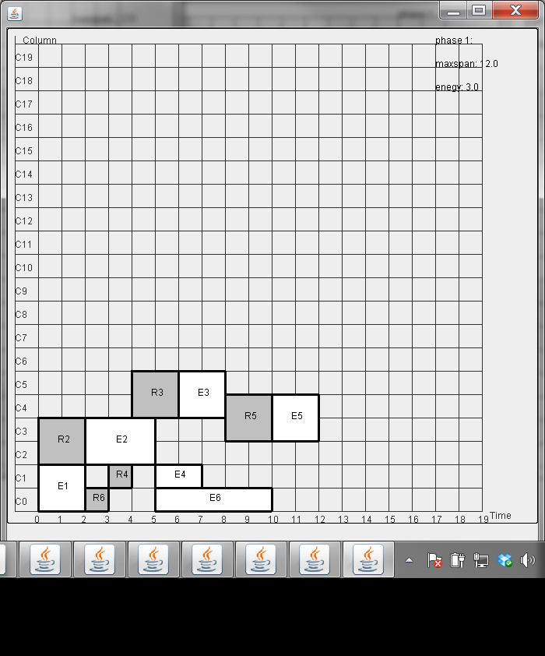

Exmaple 1- with leakage aware placement lk=100, est>200 (est>>lk)

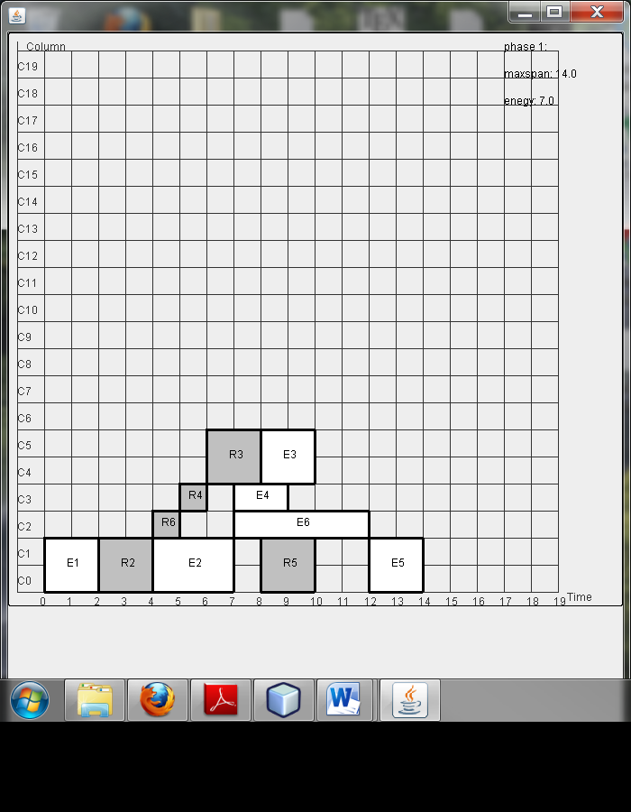

Exmaple 1- with leakage aware placement lk=0, est=2 (est>>lk)

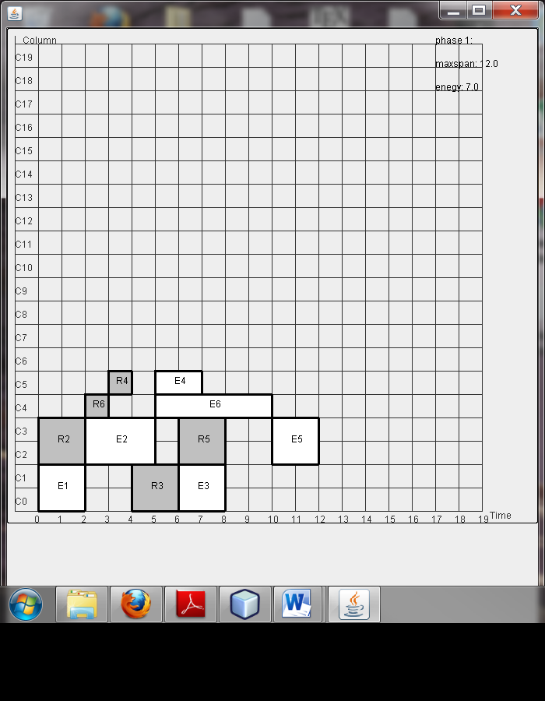

Exmaple 1- with leakage aware placement lk=100, est>200 (est>>lk)

Without leakage placement